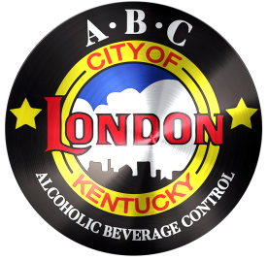
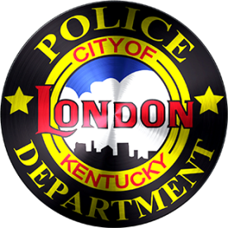
CITY OF LONDON
ALCOHOLIC BEVERAGE CONTROL
503 South Main Street | London, KY 40741
PHONE: 606/878-7004 | FAX: 606/878-9758
abcadmin@londonpd.com

NQ2 AND LIMITED RESTAURANT REMINDERS

-Don’t forget to ID/Card EVERYONE.
-TAKE an ID if you know it is a fake. Hold and contact the police if you are not sure. If an ID is confiscated, please notify the ABC Office.
-If any intoxicated person enters a business, call the police.
-If an intoxicated person leaves before the police arrive, give 911 Dispatch an update.
-Don’t forget to complete a City of London ABC Incident Report. Incidents have been occurring and not been reported. Remember: When in doubt, fill one out.
-After the ABC Incident Report is completed, please contact the ABC Office.
-Refusing to serve is OK and you have the right to do so. Just remember the liability involved when serving and selling alcohol.
-When serving, be mindful of excessive alcohol consumption by the customer.
-If an intoxicated customer is cut off or refused to be served, do not allow them an opportunity to leave without a sober driver. CALL the police. ALSO, prevent anyone else from providing the individual with alcohol.
-If alcoholic beverages are missing, call 911 and have a police report made for theft. ALSO, don’t forget to complete an ABC Incident Report and notify the ABC Office.
-Certified Alcohol Server training verifications must be kept where any officer can verify.
-Updated Alcohol Server training verifications must be turned into the ABC Office. This needs to be an official state document, copy of an official state document, or photo copies of Server certification cards. No handwritten or typed list of certified employees will be accepted.
-Regulatory Fees are to be paid monthly to the ABC Office no later than the 20th day of the month.

