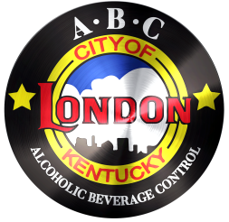
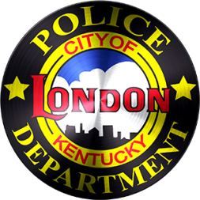
CITY OF LONDON
ALCOHOLIC BEVERAGE CONTROL
503 South Main Street | London, KY 40741
PHONE: 606/878-7004 | FAX: 606/878-9758

§ ABC Package Alcohol Sales Checklist §

- STATE LICENSE POSTED

- CITY LICENSE POSTED

- SIGN READING SALES OF ALCOHOLIC BEVERAGES ARE PROHIBITED TO ANY PERSON UNDER THE AGE OF 21 POSTED

- HEALTH & FAMILY SIGN POSTED WARNING OF DRINKING ALCOHOL DURING PREGNANCY

- SIGN WITH LETTERING NOT LESS THAN TWO INCHES IN HEIGHT READING, “NO SALES AFTER 1:00AM WEEKDAYS OR SUNDAY BEFORE 11:00AM OR SUNDAY AFTER 12:00AM” POSTED (THIS SIGN MUST BE ATOP EVERY DISPLAY AND IN CASES WHERE ESTABLISHMENTS HAVE AISLES OF MALT BEVERAGES, A LARGER SIGN, WITH LETTERS NOT LESS THAN FOUR INCHES IN HEIGHT, MUST BE PLACES AT THE ENTRANCE AND EXIT OF EACH AISLE.)

- STAR TRAINING HAS BEEN COMPLETED

- RECEIPTS ARE PREPARED FOR REGULATORY FEE

- LICENSEE’S NAME AND STATE LICENSE NUMBER(S) TO BE PRINTED ON FRONT ENTRANCE OF PREMISES IN UNIFORM LETTERS NOT LESS THAN 3” (INCHES) HIGH. AS AN EXAMPLE: 056-LD-222
JOHN DOE, INC.

