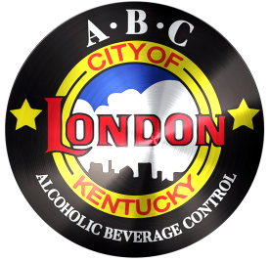
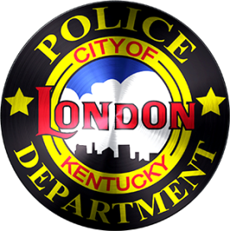
CITY OF LONDON
ALCOHOLIC BEVERAGE CONTROL
503 South Main Street | London, KY 40741
PHONE: 606/878-7004 | FAX: 606/878-9758
abcadmin@londonpd.com

NQ2 AND LIMITED RESTAURANT REMINDERS

-Don’t forget to ID/Card EVERYONE.
-TAKE an ID if you know it is a fake. Hold and contact the police if you are not sure. If an ID is confiscated, please notify the ABC Office.
-If any intoxicated person enters a business, call the police.
-If an intoxicated person leaves before the police arrive, give 911 Dispatch an update.
-Don’t forget to complete a City of London ABC Incident Report. Incidents have been occurring and not been reported. Remember: When in doubt, fill one out.
-After the ABC Incident Report is completed, please contact the ABC Office.
-Refusing to serve is OK and you have the right to do so. Just remember the liability involved when serving and selling alcohol.
-When serving, be mindful of excessive alcohol consumption by the customer.
-If an intoxicated customer is cut off or refused to be served, do not allow them an opportunity to leave without a sober driver. CALL the police. ALSO, prevent anyone else from providing the individual with alcohol.
-If alcoholic beverages are missing, call 911 and have a police report made for theft. ALSO, don’t forget to complete an ABC Incident Report and notify the ABC Office.
-Certified Alcohol Server training verifications must be kept where any officer can verify.
-Updated Alcohol Server training verifications must be turned into the ABC Office quarterly.
-Regulatory Fees are to be paid monthly to the ABC Office no later than the 20th day of the month.

