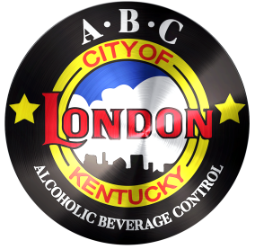
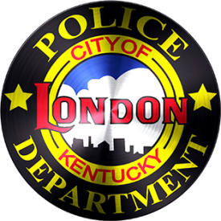
CITY OF LONDON
ALCOHOLIC BEVERAGE CONTROL
503 South Main Street
London, KY 40741
Phone: 606/878-7004 Fax: 606/878-9758
abcadmin@londonpd.com
___________________________________________________________________________________________________________________________________
COMPLAINT FORM

In order to help us effectively investigate your concerns, please fill the form below with as much information as possible. The more details you provide the more thoroughly we will be able it look into your complaint. Although not needed, your contact information is very important to us in conducting an investigation and we will do everything possible to keep that information confidential.
Thank you for your concern and assistance.
* Indicates Required Fields

Violator Details
___________________________________________________________
*Name of the business or individual
Location
_____________________________________________________________
*Location description or Address
Date & Time
_____________________________________________________________
*Date and time you observed the violation:
When do you think would be the best day and time for us to observe future violations: ___________________________________________________

Nature of Complaint

*Complaint Details: ____________________________________________

Please enter your contact information below (Optional)

Name: __________________________________________________

Phone Number(s): _________________________________________

Email Address: _____________________________________________

**Completed form can be filed in person, emailed, faxed or mailed.**

